***Sensor HC-SR04***

t emits an ultrasound at 40 000 Hz which travels through the air and if there is an object or obstacle on its path It will bounce back to the module. Considering the travel time and the speed of the sound you can calculate the distance.

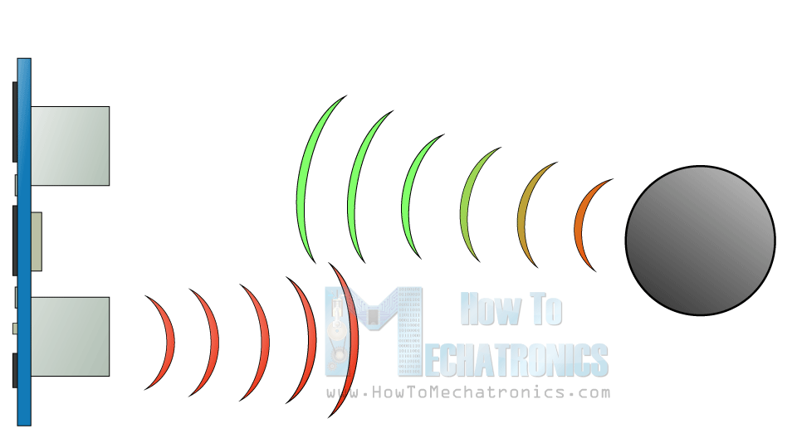

The HC-SR04 Ultrasonic Module has 4 pins, Ground, VCC, Trig and Echo. The Ground and the VCC pins of the module needs to be connected to the Ground and the 5 volts pins on the Arduino Board respectively and the trig and echo pins to any Digital I/O pin on the Arduino Board.

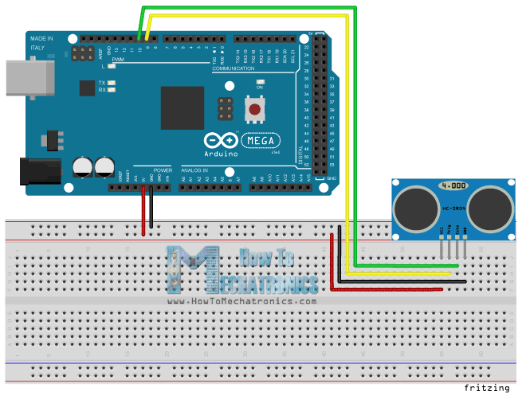

In order to generate the ultrasound you need to set the Trig on a High State for 10 µs. That will send out an 8 cycle sonic burst which will travel at the speed sound and it will be received in the Echo pin. The Echo pin will output the time in microseconds the sound wave traveled.

[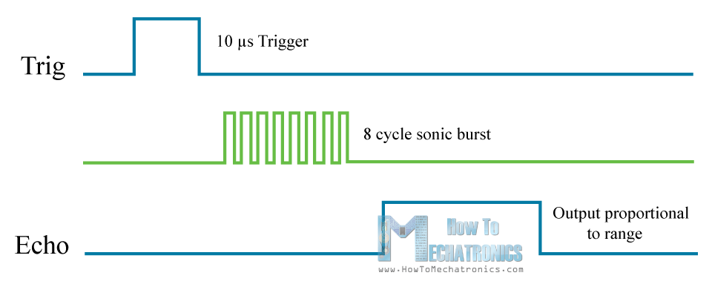](https://howtomechatronics.com/wp-content/uploads/2015/07/Ultrasonic-Sensor-Diagram.png)

For example, if the object is 10 cm away from the sensor, and the speed of the sound is 340 m/s or 0.034 cm/µs the sound wave will need to travel about 294 u seconds. But what you will get from the Echo pin will be double that number because the sound wave needs to travel forward and bounce backward.  So in order to get the distance in cm we need to multiply the received travel time value from the echo pin by 0.034 and divide it by 2.

[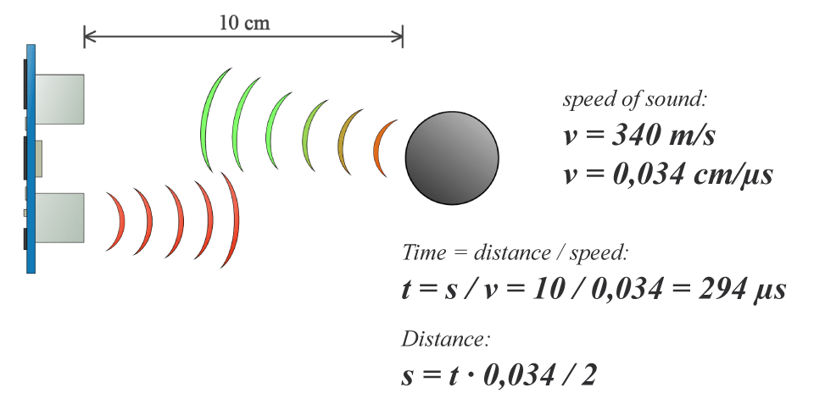](https://howtomechatronics.com/wp-content/uploads/2015/07/Ultrasonic-Sensor-Equasions.png)